Object

🔹 What is Object
# Source: AI Source: Provided by: [Data Path: Persons Table -> ID Column: 1, Name_En Column: Motasem Essam] -> From: [Chatgpt (GPT-4-turbo)] on [8/3/2025]
An object is a noun, pronoun, or noun phrase that receives the action of a verb or completes the meaning of a preposition or verb.
🧠 It usually follows the verb and answers "what?" or "whom?"

✅ Main Types of Objects:
# Source: AI Source: Provided by: [Data Path: Persons Table -> ID Column: 1, Name_En Column: Motasem Essam] -> From: [Chatgpt (GPT-4-turbo)] on [8/3/2025]
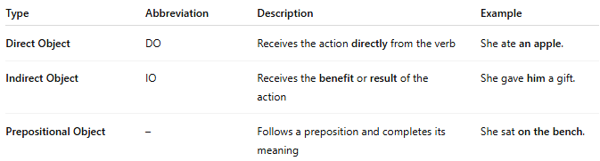
Type | Abbreviation | Description | Example
Direct Object | DO | Receives the action directly from the verb | She ate an apple.
Indirect Object | IO | Receives the benefit or result of the action | She gave him a gift.
Prepositional Object | – | Follows a preposition and completes its meaning | She sat on the bench.

✅ 1. Direct Object (DO):
# Source: AI Source: Provided by: [Data Path: Persons Table -> ID Column: 1, Name_En Column: Motasem Essam] -> From: [Chatgpt (GPT-4-turbo)] on [8/3/2025]
➤ Definition:
The noun or pronoun that directly receives the action of a transitive verb.
- Verb + what/whom? → Direct Object
➤ Examples:
- He built a house.
- They invited her.
- She found the keys.

✅ 2. Indirect Object (IO):
# Source: AI Source: Provided by: [Data Path: Persons Table -> ID Column: 1, Name_En Column: Motasem Essam] -> From: [Chatgpt (GPT-4-turbo)] on [8/3/2025]
➤ Definition:
A noun or pronoun that tells to whom or for whom the action is done.
It usually comes before the direct object.
- Verb + to/for whom? → Indirect Object
➤ Examples:
- He gave me a gift.
- She told the children a story.
- I made you some tea.
🔁 You can also use a prepositional form:
- He gave a gift to me.
- I made some tea for you.

✅ 3. Prepositional Object:
# Source: AI Source: Provided by: [Data Path: Persons Table -> ID Column: 1, Name_En Column: Motasem Essam] -> From: [Chatgpt (GPT-4-turbo)] on [8/3/2025]
➤ Definition:
A noun or noun phrase that follows a preposition and completes its meaning.
➤ Examples:
- She looked at the stars.
- He walked into the room.
- The book is on the table.

✅ Compound Objects:
# Source: AI Source: Provided by: [Data Path: Persons Table -> ID Column: 1, Name_En Column: Motasem Essam] -> From: [Chatgpt (GPT-4-turbo)] on [8/3/2025]
- When two or more objects appear together, they're called compound.
➤ Example:
- She bought apples and oranges.
- They invited you and me to dinner.

✅ Object Position in Sentences:
# Source: AI Source: Provided by: [Data Path: Persons Table -> ID Column: 1, Name_En Column: Motasem Essam] -> From: [Chatgpt (GPT-4-turbo)] on [8/3/2025]
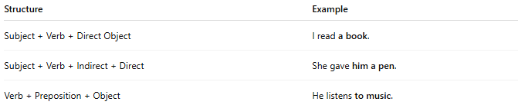
Structure | Example
Subject + Verb + Direct Object | I read a book.
Subject + Verb + Indirect + Direct | She gave him a pen.
Verb + Preposition + Object | He listens to music.

✅ Object vs Complement:
# Source: AI Source: Provided by: [Data Path: Persons Table -> ID Column: 1, Name_En Column: Motasem Essam] -> From: [Chatgpt (GPT-4-turbo)] on [8/3/2025]
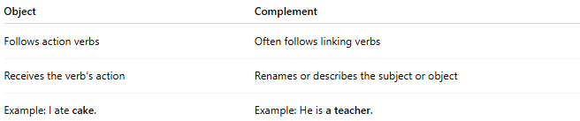
Object | Complement
Follows action verbs | Often follows linking verbs
Receives the verb’s action | Renames or describes the subject or object
Example: I ate cake. | Example: He is a teacher.

📝 Summary:
# Source: AI Source: Provided by: [Data Path: Persons Table -> ID Column: 1, Name_En Column: Motasem Essam] -> From: [Chatgpt (GPT-4-turbo)] on [8/3/2025]
- An object completes the action or meaning of a verb or preposition.
- Direct objects receive the action; indirect objects benefit from the action; prepositional objects follow prepositions.
- Objects can be simple, compound, or part of clauses.

